Dear Community members,

The Mad City Badgers Wheelchair Basketball Team will be hosting a Fundraiser and Demonstration Night at Hillsboro High School, May 4th starting at 4pm-7pm. This event will be FREE, and all are welcome to attend and learn more about the Mad City Wheelchair Sports Program and give Dodge a great last HOOAH!!!
At the Event we will have:
*Basket Raffle
*Team Demonstration
*Wheelchair Basketball Game featuring the Mad City Badgers vs Hillsboro High School Boys and Girls Basketball Team!

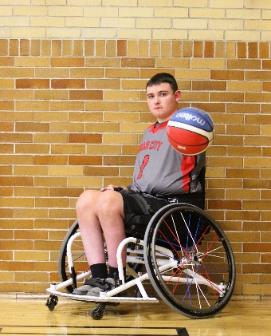
Dodge Shore is a Senior at Hillsboro Highschool and has always had a love of the game. In July 2017 that changed. He and his sister and brother were involved in a head on collision that caused Dodge to become paraplegic due to a spinal cord injury. After 42 days in the American Family Children’s Hospital in Madison, he went home not knowing what he was going to do. After some internet research by his mom they were connected with Amy Spangler, coach of the Mad City Badgers. On a Tuesday night Dodge and his mom went to the Blackhawk church in Middleton to check out practice. That night, Dodge came home with a jersey and became an official member of the team. For the past 7 seasons, Dodge has been able to continue to play the sport that he thought he’d never get to play again. Being on the team has benefited Dodge so much. He has made many new friends from all over the country. He has also gotten to travel to different cities for tournaments. He has also helped mentor younger kids on the game. Thanks to playing and working so hard, Dodge will be able to continue his basketball career with the UW Whitewater Warhawks Men’s Wheelchair Basketball time. But before he leaves the team, he wanted to do one more fundraiser to help the team that has helped him. This fundraiser will be his last ‘HOORAH’ before he graduates from Highschool and leaves The Mad City Badgers.

Mad City Badgers are sponsored by Mad City Wheelchair Sports, Inc., which is a nonprofit 501(c)(3) organization. Local communities and schools are not able to provide a competitive basketball environment where these athletes can compete with like abled individuals. Therefore, it is the mission of Mad City Wheelchair Sports, Inc. to provide this experience for these individuals age 8 to 18. The team is comprised of athletes who live in the western half of the state of Wisconsin. In order to continue expanding the program to reach more families and areas, the Team must reach out for support from the local communities. Supporting wheelchair athletics involves expenses paid by the Mad City Wheelchair Sports organization and individual families; these expenses include tournament fees, equipment, facility fees, and transportation fees.

We are reaching out to ask for your support for this amazing program. We are seeking Basket Raffle Donations or Gift Certificates as well as Monetary Donations.
Come see what Wheelchair Basketball is all about on May 4th and meet the Mad City Badgers Wheelchair Basketball Team!
Tax Deductible Monetary Donations can be made out to:
Mad City Wheelchair Sports and prior to the event they can be mailed to:
Brandi Bloor 733 Hillsborough Ave. Hillsboro, WI 54634
Basket Donations will need to be picked up/dropped off by 4/3/2-contact Brandi for arrangements (608)604-0964.
Venmo: @Brandi-Bloor and put Fundraiser in the box.

