Yearly Expenses for Highschool Basketball Player | Family Cost | Yearly Expenses for Wheelchair Basketball Player | Family Cost
Participation Fee | $100 | Team Participation Fee | $150
Basketball Shoes | $125 | League Registration | $35
Transportation | $0 | Transportation to practice 1x per week for furthest family | Up to $50 x 32 =  $1600-$1800
Transportation to Games | $0 | Transportation to games per Tournaments | $100 -$150 x 6 =  $600-$900
Lodging For Games | $0 | Lodging for Games/Tournaments | $350 x 6 =  $2100-$2500
 |  | Tires and Tubes for Wheels | $60
Estimate Yearly Cost | $200 | Estimate Yealy Cost | $4545 -$5445

Additional Wheelchair Basketball Expenses | Family Cost
Basketball Wheelchair | $2500-$4000 every 3 years

Wheelchair Basketball (Expenses H.S. Teams do not have) | Team Expenses
NWBA TEAM Dues | $775
Gym/Facility Rental – Practices 32 x 3 = 96 hours | 96 x ($20 - $50 per hour) = $1920 - $4800
Tournament Fees (Pays for facility and referee fees) | 6 x 400 = $2400

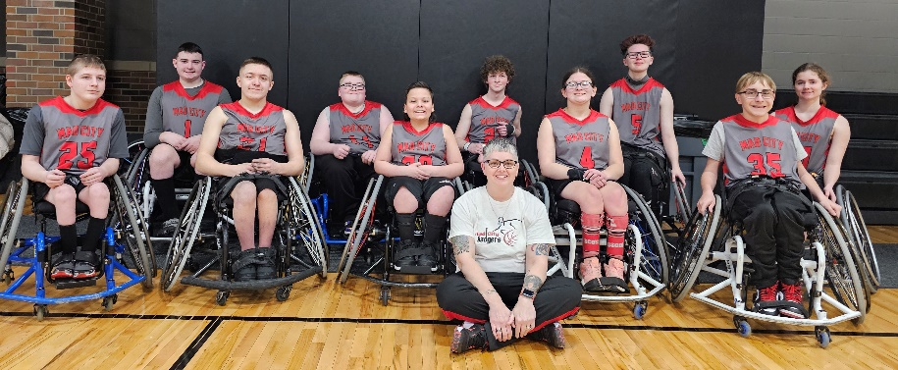
Amy Spangler – Head Coach
madcitywheelchairsports@gmail.com
608 501 5946

Brandi Bloor – Team Representative
brandijean98@hotmail.com
608 604 0964

